How to Create a Post
Step 1: Brainstorm a post that is worthy of sharing. Will it include pictures or just text? Is this something to be posted publicly? These are all good questions to ask yourself.
Step 2: Click the line that reads, “What’s on your mind?” (highlighted below)
Step 3: In the text box go ahead and type your post. If there are any photos to include click the first green icon and select the desired photos. (highlighted below)
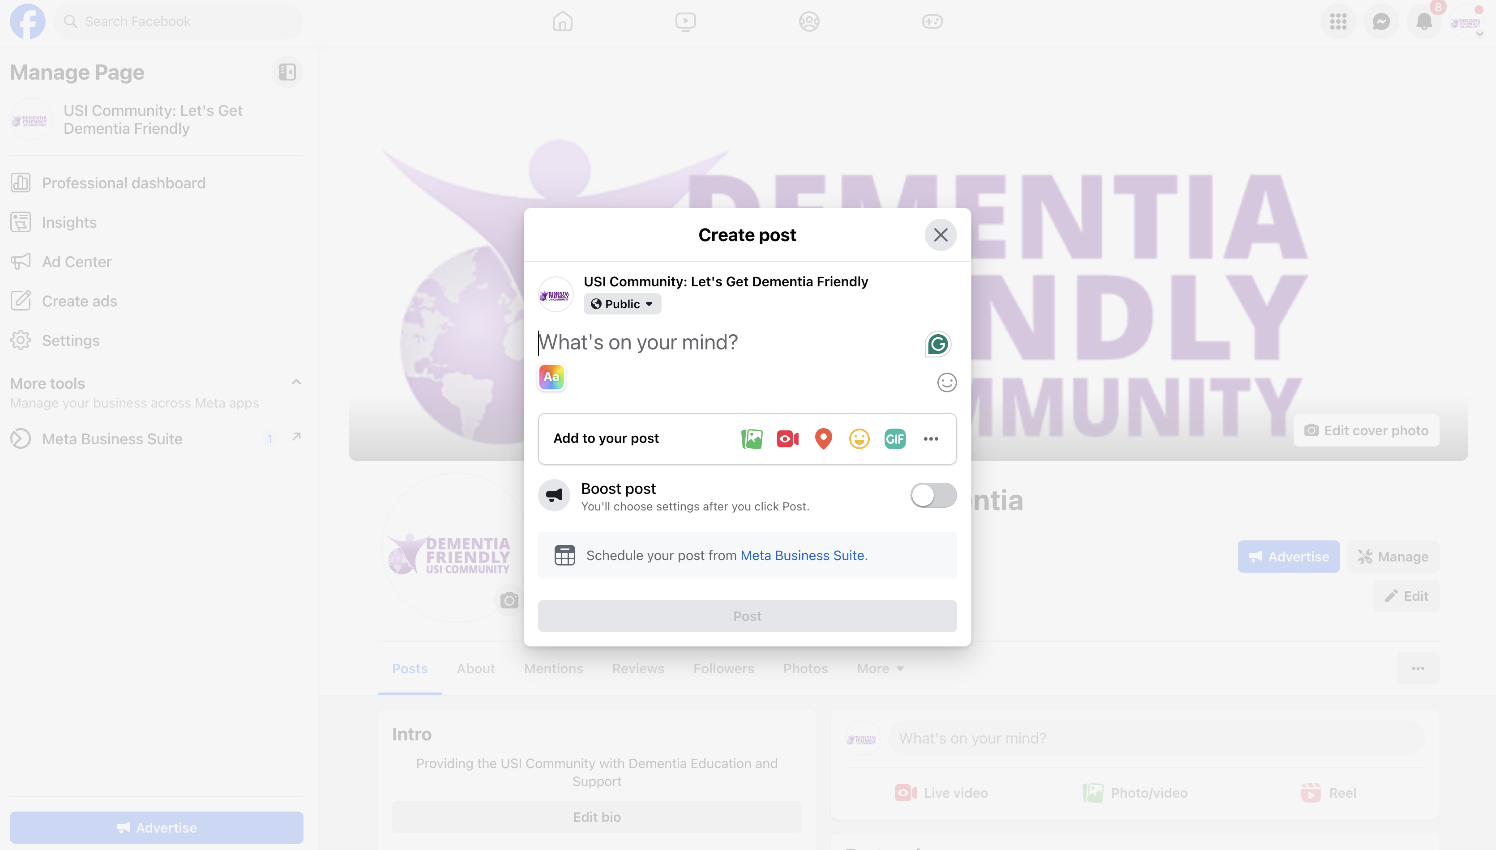
Step 4: Once you have proofed your post for any errors or mistakes, go ahead and click post, located in the bottom bar.
Step 5: Your post is now live!

