Getting Started with a Google Account
Note: Before you can create a survey using Google Forms, you need to create a Google account. You do not need a Gmail account to create a Google account. Google Forms offers a free way to administer your survey online.
- The first step is to go to the Google Account sign in page.
- Next, click on Create Account.
- Enter your name for the account. If you already have a Google account, the name will help you discern between multiple Google accounts. If the name for the personal account is “Wright,” then the name for the account that is administering the survey should be “DFCWright”. This is different from your username.
- Now for this step, you can either choose to create a new Gmail account and username, or you can use an existing email address from a non-Gmail account. Note: If you already have a Gmail account, you may want to create a new one so you can separate the survey work from your personal account.
  - If you are making a Gmail account:
    - In the “Username” field, enter a username
    - Enter and confirm your password
    - Click next (Optional: Add and verify a phone number for your account.)
    - Click next again
  - If you are using a non-Gmail address:
    - Click “Use my current email address instead.”
    - Enter your current email address
    - Click next
    - Verify email address with the code sent to your existing email
    - Click Verify
- After you have completed these steps, you should now have a usable Google account! The next page of this handout will show you how to access Google Forms.

How to access Google Forms

- Once you have created a Google Account, you should be ready to use Google Forms!
- When you open Google Chrome (internet browser), you should be met with the following screen.
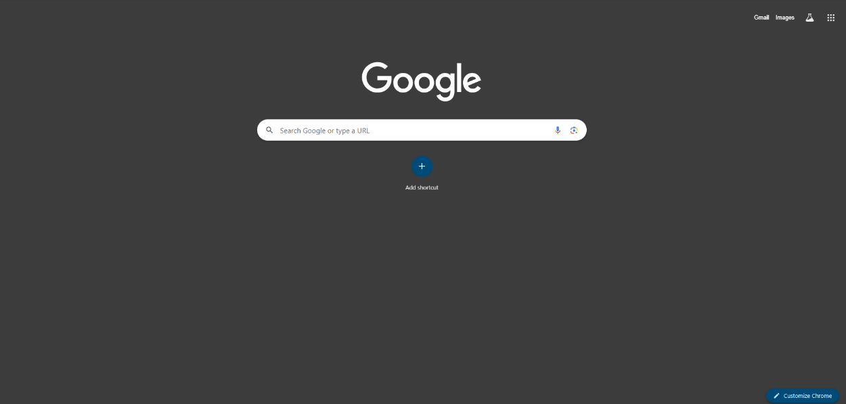
- Once you are there, click on the 9 dots at the very top right corner, circled in red below.
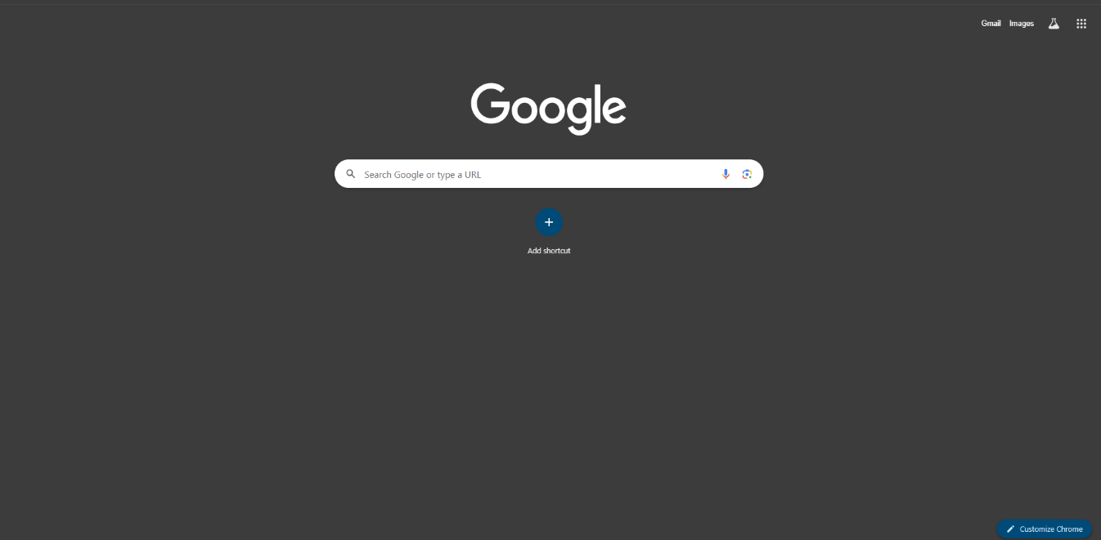
- Once you click on that, it should bring up a variety of different Google apps. Scroll down to the bottom where you can find “Forms” with a purple logo, located in the middle of the second to last row.
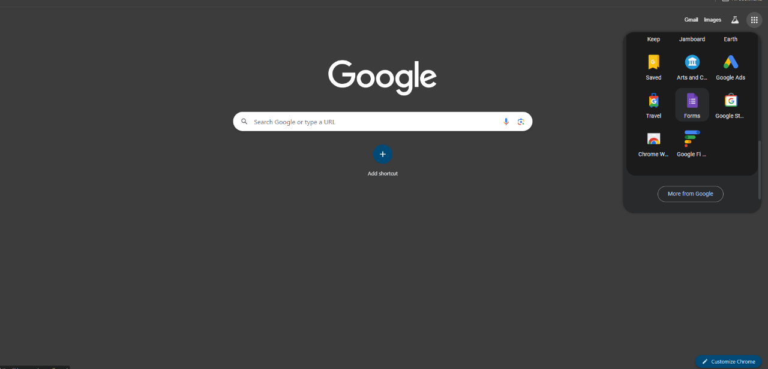
- You should now be on the home screen for Google Forms! To start, you can choose an existing template or start a new form.
