*University of Southern Indiana Center for Communal Studies*

*Fall 2024 Board of Advisor Meeting*

CCS Board Meeting Time Oct 23, 2024 10:30 AM Central Time (US and Canada)

Meeting ID 969 3655 1912

Invite Link <https://usi.zoom.us/j/96936551912>

CCS Lecture Time Oct 23, 2024 01:00 PM Central Time (US and Canada)

Meeting ID 915 8417 1871

Invite Link <https://usi.zoom.us/j/91584171871>

Board Members Present

Dr. Gregory W. Brown (Retired Principal Christa McCauliffe Alternative Middle School); Ms. Jennifer Greene (Archivist Librarian, USI); Ms. Leslie Townshend (Director Community Engagement, USI); Dr. Del Doughty (Dean, College of Liberal Arts); Ms. Marna Hostetler (Director Rice Library, USI); Dr. Matthew Hanka (Professor of Political Science, USI); Mr. G. Graham Perry III (Tennessee Historical Society Columbia State Community College; Dr. Andrew Buck (Professor of Sociology, USI); Dr. Matthew Hanka (Professor of Political Science, USI); Dr. Mike Strezewski (Professor of Anthropology, USI); Dr. Kelly Kaelin (Assistant Professor of History; USI);

Absent Members

Dr. Joshua Lockyer **(**Professor of Anthropology Arkansas Tech University); Donald E. Janzen (Retired Consulting); Dr. Donald Pitzer (Professor Emeritus of History, Director Emeritus Center for Communal Studies, USI); Dr. Kristalyn Shefveland (Assistant Dean, College of Liberal Arts, Professor of History, USI); Wendy Bredhold (Senior Manager Transmission Initiative National Audubon Society’s Climate Team); Dr. Franziska Bechtel (Research Associate, Insitut für Theologie, Diakonie, Ethik AGAPLESION gAG, Frankfurt Germany)

Director

Dr. Silvia Rode (Assistant Dean, College of Liberal Arts; Professor of German, USI);

Center Location

University of Southern Indiana, University Archives and Special Collections (David L. Rice Library, Communal Studies Reading Room 3022)

1. Welcome, Acknowledgements & Promotions

* Ms. Julie Cox, administrative assistant provided logistical help for board meetings
* Dr. Kelly Kaelin gave birth to a baby boy
* Dr. Andrew was promoted to Professor of Sociology
* Dr. Kristalyn Shefveland was promoted to Professor of History
* Dr. Mike Strezewski was promoted to Professor of Anthropology

Recipient of the 2024 College of Liberal Arts Distinguished Faculty Award

* Dr. Carol Medlicott retired from Northern Kentucky University

Recipient of the 2024 CSA Distinguished Scholar Award

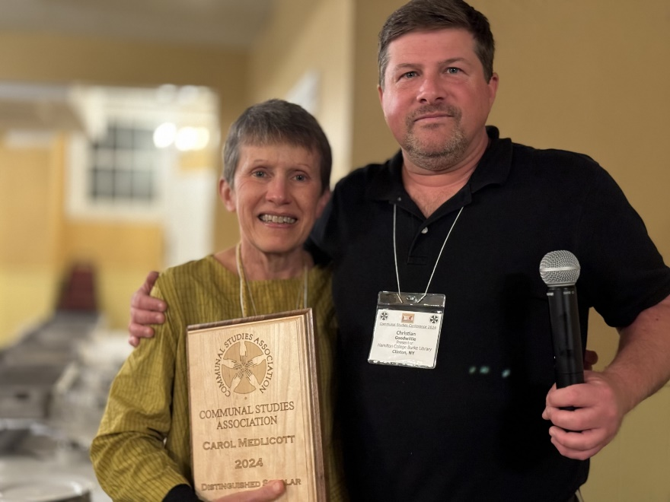

* Ms. Wendy Bredhold accepted a new position as Senior Manager at the Transmission Initiative National Audubon Society’s Climate Team
* Ms. Jennifer Greene for her flexibility in hosting scholars

1. Board Member Approval
2. Board Members (term expiration 2024)

Dr. Greg Brown (willing to serve another four-year term); Dr. Joshua Lockyer (willing to serve another four-year term); Mr. G. Graham Perry III (willing to serve another four-year term); Dr. Donald Janzen (willing to serve another four-year term); Dr. Franziska Bechtel (willing to serve another four-year term)

Vote: The beforementioned board members were unanimously approved to service another four-year term.

1. Opening the floor for new board member suggestions
2. Approval of Annual Board Report 2023/2024
3. Update Communal Studies Minor (Dr. Andrew Buck)

* Creation of a 200-level interdisciplinary Core39 communal studies course.
* Possible title: Models of Community: Past, Present, and Future. Ask students for feedback and perceptions of possible course titles.
* Create a communal studies prefix.
* Use momentum and advertising possibilities in connection with the UNIV New Harmony experience. New course should be marketed as a spring option following UNIV HN experience in fall.

1. New Harmony and CCS Updates
2. HNH participated in an auction for New Harmony books.

* A manuscript on hymnals compiled by Harmonist member Jacob Neff. It contained “travel songs” documenting the founding of Harmonist settlements in America. Unfortunately, HNH lost out to a private collector. The information was passed along to the buyer, but no answer. There is hope that the buyer would be willing to lend it to us for research and exhibit display purposes.
* A first-edition book published by the Harmony Society in 1826. It contains the results of a prose and poetry competition among members at New harmony. This collection of verses and short essays remains largely untranslated but reveals the spiritual and temporal emotions of a cross-section of ordinary Harmonists. HNH was fortunate to acquire this item.
* Exhibition at the Indiana State Historical Society

1. Upcoming 200th Robert Owen Anniversary (2025)
2. Dr. Hitchcock is translating a short play by Raul Hernandez Garrido, a Spanish playwright who spent time at USI as a scholar-in-residence. The anthology (Páginas de New Harmony) includes other plays on HN and Indiana, some of them from the “Contemporary Spanish Theater: Stages of Utopia. Dystopia, and Myopia” Conference in New Harmony. This particular play is based on a fictional conversation between Robert Owen and his wife Caroline and the questions “No hay tal lugar? [There is no such place?].” Rode will write an introduction for the English publication.
3. Upcoming 50th Anniversary of the International Communal Studies ICSA (2026)
4. Academic Outreach and Engagement
5. Fulbright research scholar applications

* Dr. Claudia Roesch, University of Konstanz, Institute for History, Sociology, and Empirical Education Research, Germany. (successful)
* Dr. Paola Ferruta, Associate to the IHTP, Aubervilliers and Centre Roland Mousnier, University Paris-Sorbonne, France. (rejected)

1. Presentation “Christoph Weber: Pottery Production in the Harmony Society, 1808-1853.” Indiana Historical Society. (Dr. Strezewski)
2. Dr. Carol Medlicott was featured speaker at the 250th Shaker Anniversary conference in Maine.
3. Research fellow hosting (Rode/Greene)

* Dr. Dirk Johannsen, University of Oslo, Norway
* Dr. Ashley Rattner, Jacksonville State University
* Dr. Paola Ferruta, Aubervilliers and Centre Roland Mousnier, University Paris-Sorbonne, France
* Dr. Claudia Roesch, University of Konstanz, Germany. Recipient of a Fulbright Award, sponsored by the Center for Communal Studies.
* Dr. Victoria Phillips, London School of Economics and Global Fellow, Woodrow Wilson International Center for Scholars, London, England
* Dr. Anja Kirsch, Norwegian University of Science and Technology, Trondheim, Norway
* Dr. Tristra Newyear, Editor Frances Wright: America’s Forgotten Radical.
* Utopia and the Harmonists presentation for Frances Wright Retreat, New Harmony (Rode)

1. Frances Wright Podcast [https://kite.link/radicalfannywright](https://nam11.safelinks.protection.outlook.com/?url=https%3A%2F%2Fkite.link%2Fradicalfannywright&data=05%7C02%7Csarode%40usi.edu%7C1e724f8b581645e4e5d608dce255878c%7Cae1d882c786b492c90953d81d0a2f615%7C0%7C0%7C638634104218681900%7CUnknown%7CTWFpbGZsb3d8eyJWIjoiMC4wLjAwMDAiLCJQIjoiV2luMzIiLCJBTiI6Ik1haWwiLCJXVCI6Mn0%3D%7C0%7C%7C%7C&sdata=vA57NuM%2BsGHQuNf5MzIHowtlKy6UrfMeRDHrPiXMHsU%3D&reserved=0) (Rode)
2. Interview Research Travel Grant recipient <https://www.youtube.com/watch?v=dlEkxKMSx8I> (Rode)
3. Center for Communal Studies presentation at USI’s New Faculty Orientation in New Harmony (Rode)
4. Prizes Review Committees

Volunteers for Undergraduate/Graduate Review Committee and Travel Research Grant Review Committee.

Undergraduate/graduate review committee members: Dr. Carol Medlicott; Dr. Kelly Kaelin; Dr. Matt Hanka; Dr. Del Doughty

Research Travel Grant review committee members: Mr. Graham Perry; Ms. Jennifer Greene; Dr. Greg Brown

1. Fall lecture

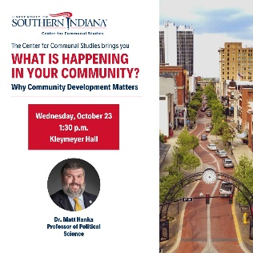

51 participants

1. Spring Lecture Suggestions

The Farm scholar (Graham Perry); Grateful Dead (Del Doughty); Shaker Owenite scholar (Carol Medlicott)

1. Collection Development
2. New archival acquisitions

* John Martin Smith. Possible donation of Indiana Shaker community materials, 1818 Deed signed by President Monroe granted lands that the West Union/Busro was built and other related materials. The materials are coming from the son of John Martin Smith, Shaker historian.
* Catherine McAllister donation on Brotherhood of New Life, 19th century communal group.
* Dr. Casey Harison donated a copy of *Look to the Distaff*” by Caroline Dale Baldwin Allen, 1990.

1. Reference (starting August)

11 Reference request

2- students

7- Public

2- Faculty

* Pulled 36 Harmonists & Arndt files for Dr. Michael Strezewski.
* Pulled 95 files for visiting scholar Claudia Roesch, Research Associate and Lecturer from the Department of History, Sociology, Empirical Education Research at the University of Konstanz, Germany for “Utopian Engineering: Solving the 19th Century Slavery, Labor, and the Women’s Questions with Science.” Spent over a week in archives on the CCS for Fulbright/Research Travel Grant recipient.

1. Dr. Don Janzen Report (please see materials in your packet)
2. Budget

|  |  |  |  |  |  |  |  |  |
| --- | --- | --- | --- | --- | --- | --- | --- | --- |
| 7A | Services & Supplies | $7,145.00 | $.00 | $.00 | $500.00 | $6,645.00 | 7.00% | 93.00% |
| Subtotal | Non-Personnel Expenses/ Transfers Out | $7,145.00 | $.00 | $.00 | $500.00 | $6,645.00 | 7.00% | 93.00% |