Using Google Forms to Create an Online BKAD Survey

Instructional Guide
Note: Instructions on how to create a Google account and how to access Google Forms are provided in a separate handout. This handout provides instructions on how to construct the Basic Knowledge About Alzheimer’s Disease (BKAD) survey in Google Forms. Background information about the BKAD survey is provided in the MS Word survey document in the DFC Resource Corner on the Bronstein Center for Healthy Aging and Wellness website. We recommend that DFCs build an online BKAD survey by copying and pasting the survey description and items from Word into the Google Form. Copying and pasting the survey text, rather than re-typing, will decrease typographical errors.

- Once you have signed up to use Google Forms, head to Forms to begin creating your survey. There are many templates to choose from but for this survey we are going to use the "Blank Quiz” template.
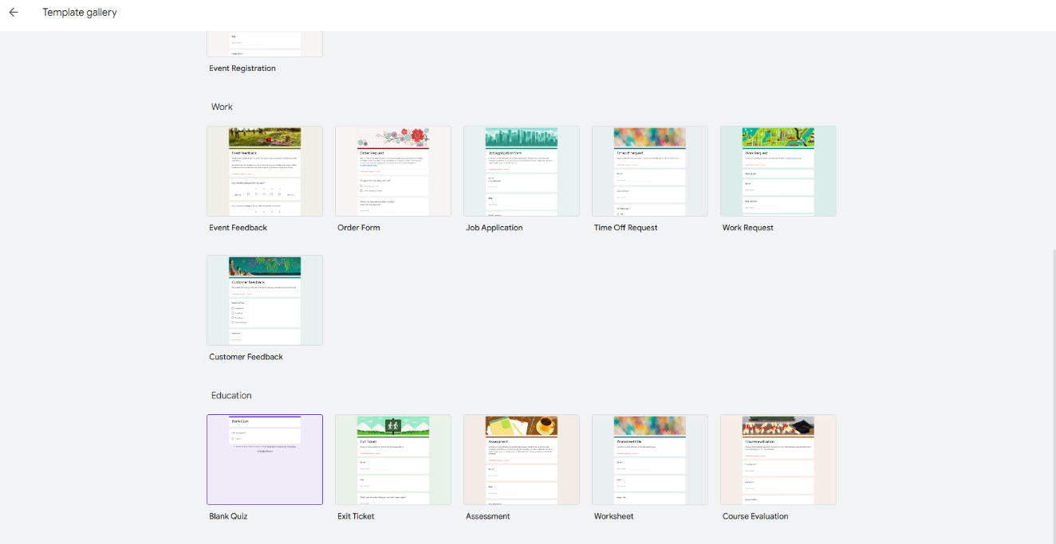

- The screen showing your selected template will appear as shown below.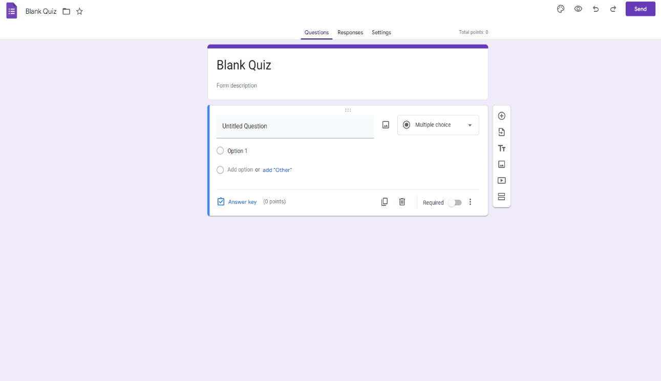

- Next, change the title of Section 1 to “Basic Knowledge of Alzheimer’s Disease (BKAD)” and enter the narrative from the BKAD Word document into the form description. Then, since we do not need the question block under the description, you will delete that.
You survey should look like this now: 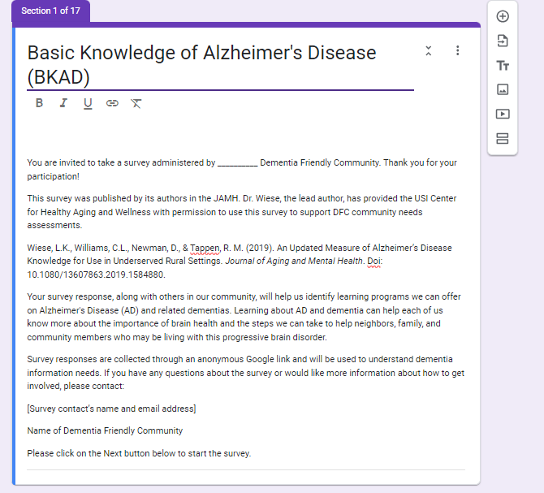

- To create Section 2, click on “Add Section” to the right of the block (circled in red).

- Once Section 2 is created, add a question to ensure only the responses of people living and/or working in your community inform the findings. Click on the “+” sign to the right of the section block to add: “Which community are you a part of?” Next, click the drop-down and change the question type, circled in red, to checkboxes. Create only two response options, one for your community and an “Other” option with a text field.
The question will look like this (ex. Posey County):
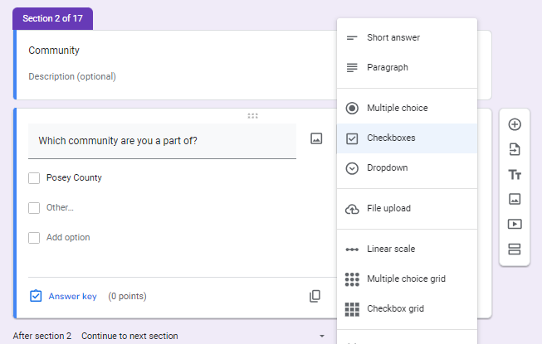

Note: At the end of the guide, we will show you how to filter out survey responses from “other” communities before analyzing survey responses.

- Repeat the process to add a new section, Section 3. The creation of the next question will be different as it requires logic. Title the section “Sector” and add your question and responses. All the DFA sectors, as defined by Dementia Friendly America, are listed in the visual below. It is important to change the question type to checkboxes so the respondent can mark multiple options that may apply to them.
It should look like this:
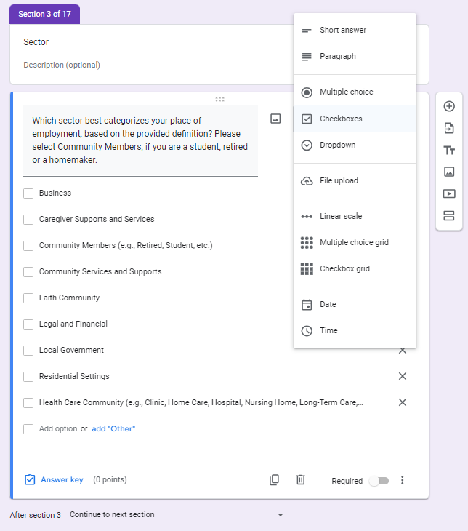
- Before logic is added, we need to first create the sections that respondents will move to depending on how they answer the previous question.
  - Create Section 4 and title it “Zip Residence”.
  - If they choose “Community Members (e.g., Retired, Student, etc.)” then we want to ask, “What is the ZIP Code of your residence?”
  - Note: At the bottom of section 4 under the form you will see the text that says, "Continue to next section." Left click on this to select from the dropdown options, select "Go to section 6 (Instructions).
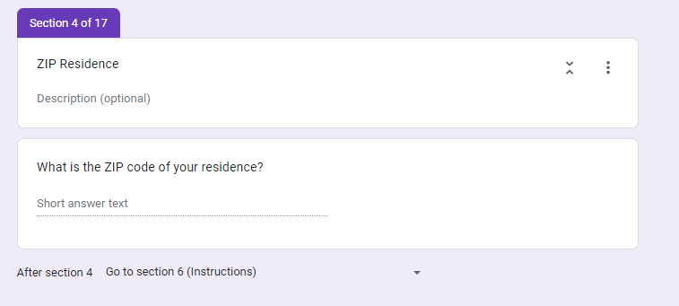

  - Next, create Section 5 and title it “Zip Employment”.
  - If they choose any of other sectors, we want to direct them to this new section, which will ask, “What is the Zip Code of your place of employment?”
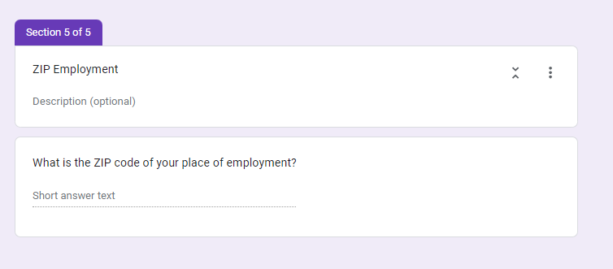
- Now it is time to go back and add logic to “Section 3” of your survey. To do so, click on the question box. It should show dropdown menus titled “Continue to next section” next to our answer choices.
  - Click on the dropdown and assign them to the proper section. Here is what it should look like now:
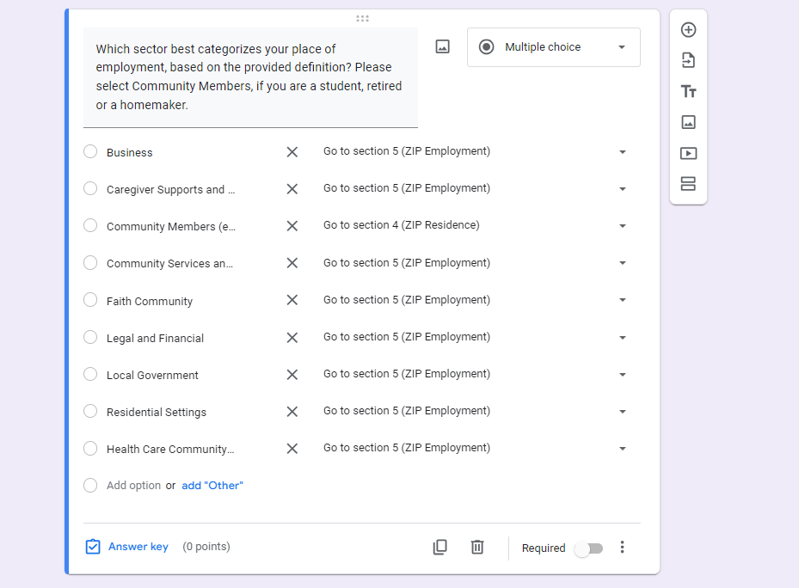

- Now, we are ready to create the main section of the survey. First, we need to create instructions for survey respondents.
  - Before you add the first question, please copy and paste the note (see survey visual below) from the BKAD MS Word document.
  - Next, add the first BKAD true/false question: “The chance of Alzheimer’s Disease is greater if a parent had it.” Then make sure the question is multiple choice and give them “True, False” answer options.
  - Since the survey is created in what Google Forms calls a “quiz” format, we want to choose what the correct answer is so the respondents can see the answers once they finish.
  - In the bottom left corner, click on “Answer Key.” For this question, the answer is True. Then assign the point value to “1”. Refer to the BKAD 2020 Revised KEY (located in the DFC Resource Corner) to apply answers to the remaining questions.
  - Here is what Section 6 should look like:
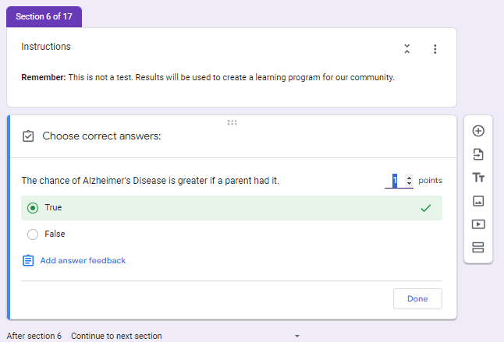
- For the remainder of the survey, copy and paste the rest of the BKAD survey questions and create True or False response options.
  - Create a new section for each subsequent set of questions and repeat the process. This will prevent the respondent from having to scroll to complete the survey.
  - Do not forget to add the point value and correct answer for each question.
  - Here are what the remaining sections should look like:
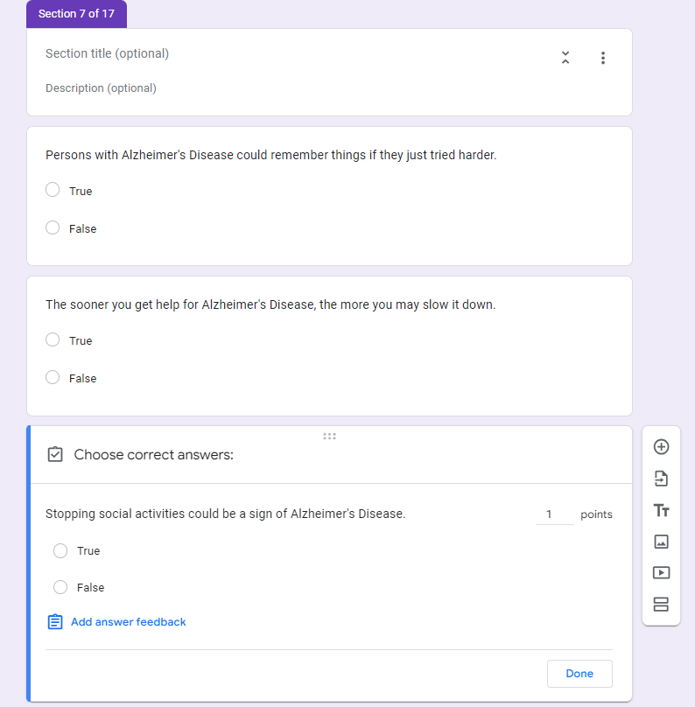

- Once you have finished adding the remaining sections and questions, we want to add a confirmation message, so respondents know they completed the survey.
  - To enable this, go to “Settings” at the top of the survey.
  - Scroll down to Presentation and click on Edit where it says, “Confirmation Message”.
  - The image below shows what text should be in the “Confirmation Message” box.
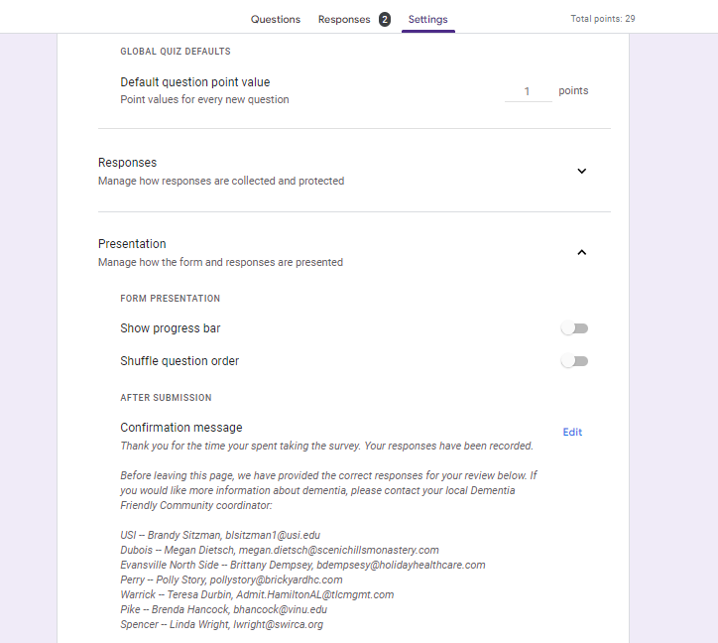

- The last thing we need to do is make sure our respondents can see the correct answers once they have finished the quiz.
  - To enable this, go to “Settings” at the top of the survey.
  - You will then see a section titled “Respondent Settings.”
  - Make sure that the following are enabled: Missed Questions, Correct answers, and Point Values.
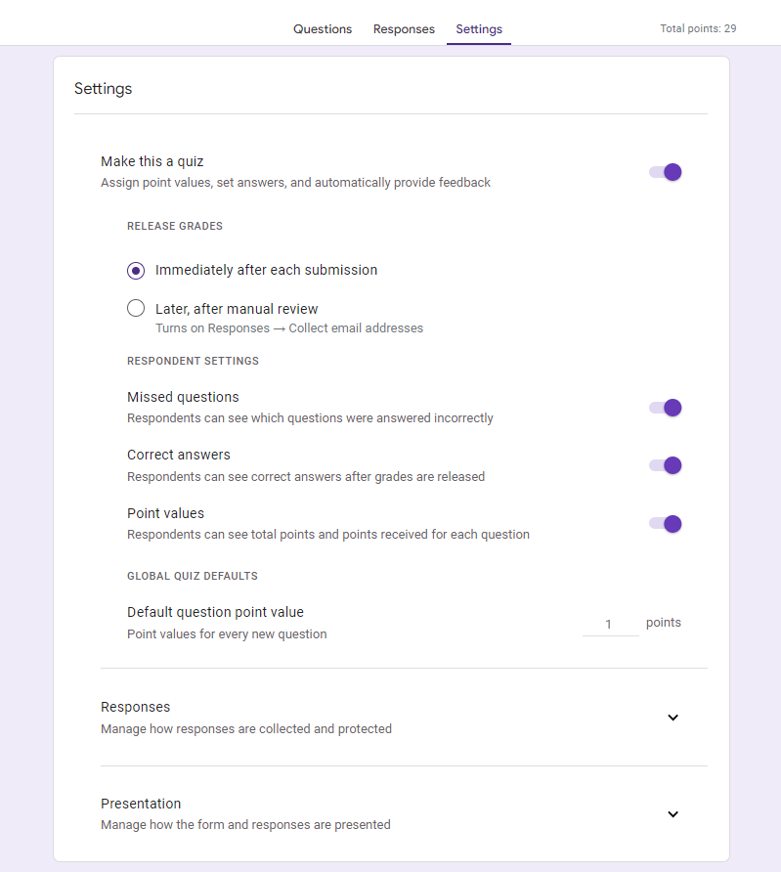

- Your survey should now be completed! Now you can preview your survey to make sure everything appears as it should prior to administration. To preview your survey, click on the eye logo at the top right of your form.

- When ready to administer the survey follow these steps:
  - To administer and access the survey link, left click on “Send” at the top right of the survey.
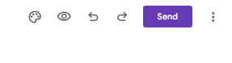
  - You can send the survey via email, copy it as a link, or embed the survey link into a website. See below.
    - If you choose to email the survey link, you will know who has and has not completed the survey. This can be helpful if you want to send reminders to complete the survey.
    - If you have promised confidentiality so that individuals don't feel nervous about how well they score on the survey, you will want to use the link. Using the link means, you will not be able to identify survey completers.
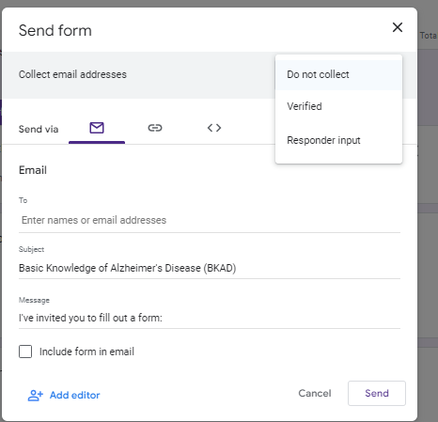
- This step will show how to filter “Other” options and how to analyze results. To do so, left click on “Responses” at the top of the form. If you have administered the survey, you will see responses as shown below. (The example provided has only 2 responses for illustration purposes.)
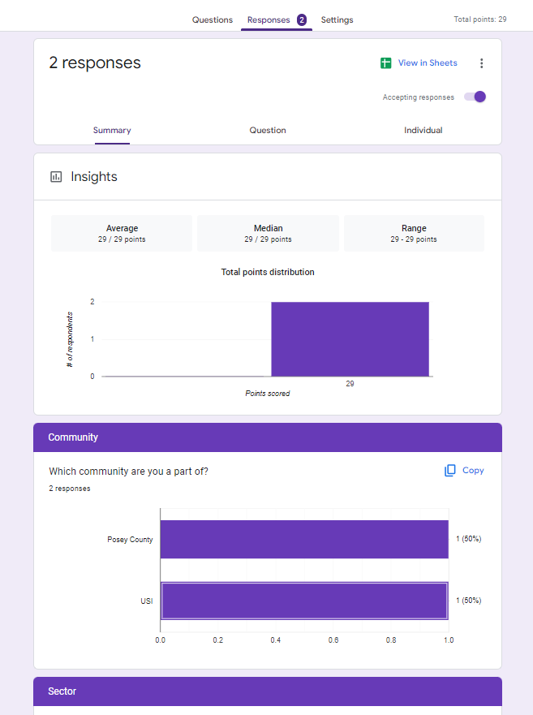
- To see complete survey records of responses, click on “View in Sheets”, which will be at the top right (circled in red in the visual shown above).
- It will then direct you to the app “Google Sheets” which is like Microsoft Excel.
- If responses have been collected, the sheet should look like the image below:
- Next, create a filter to filter “other” options in the survey. To do so, highlight and right click on Column C where it says, “Which Community are you a part of?”. Choose the option that says, “Create a filter” (circled in red below).
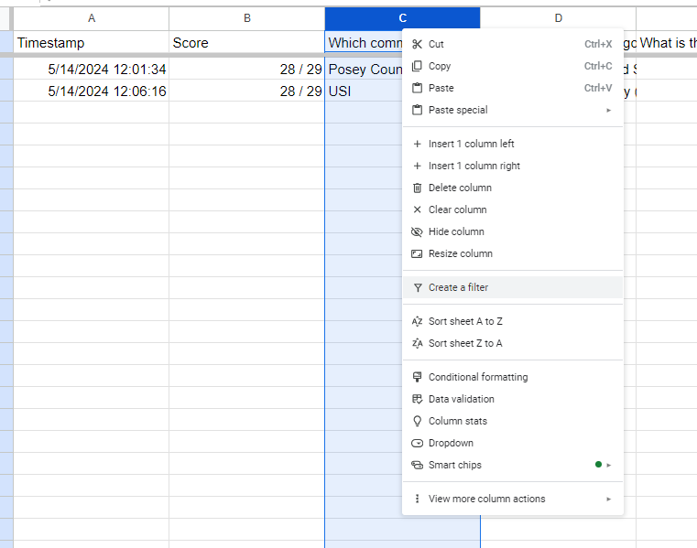

- 3 bars (circled in red) will appear at the top right of the box once the filter is created. It will look like the image shown below:
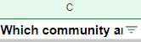

- Left click on the 3 bars and it will give a variety of filter options.
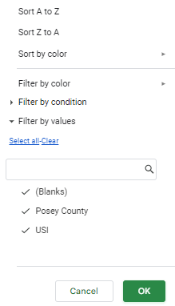

- Since Posey County is the example community for the survey, any other communities shown on this filter would mean the respondent selected “Other.” In this case it would be USI. To only see the “Other” responses, left click and uncheck the community that was given as an answer option on the survey. It should look like the picture shown below.
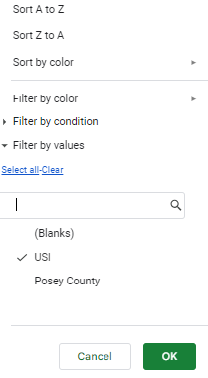
- Once the community is unchecked, the “Other” option is the only data appearing on the Google Sheet. Then, delete these responses since they don’t make sense to include in the assessment of your community. Don’t worry, if you ever need to refer to these deleted responses, they are still stored in the Google Form survey and can be downloaded again.
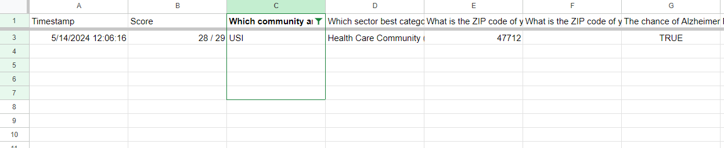
Note: There may be more options depending on how many respondents choose “Other” instead of the listed DFC option on the survey.

- When you click on “Send” the option of adding an editor to the survey appears. You may want to add an editor to share administration responsibilities. Being an editor, will allow an individual to either view or make changes to the survey depending on what level of access you grant them.

