How to create a page:
Step 1: Go to www.facebook.com and log into your account.
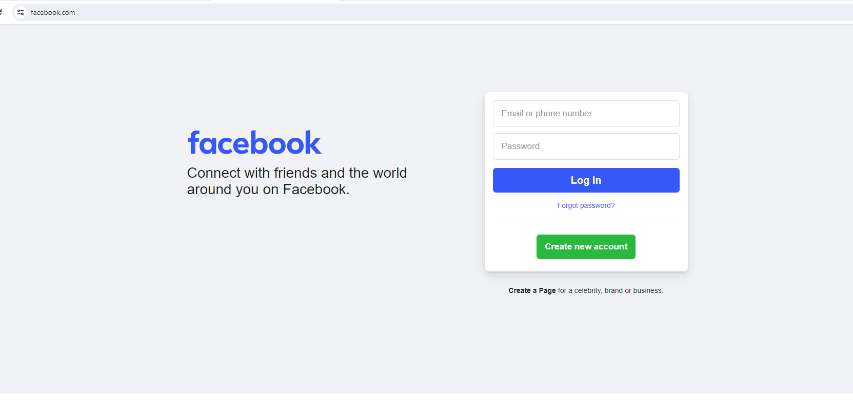
Step 2: Click on your profile picture in the upper right-hand corner.
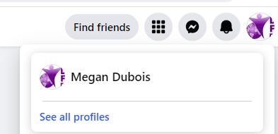

Step 3: Click on See all profiles.

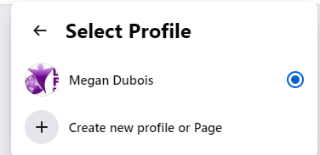
Step 4: Click on Create new profile or page.

Step 5: Select Public Page and Click Next.
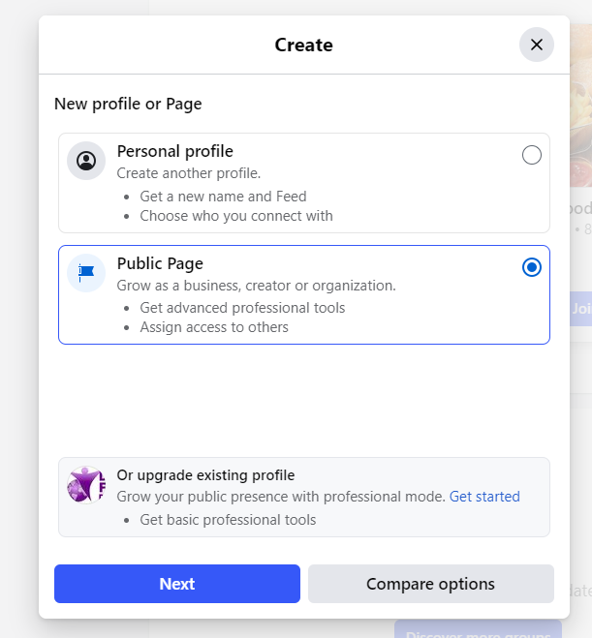

Step 6: Click Get Started

Step 7: Complete information
