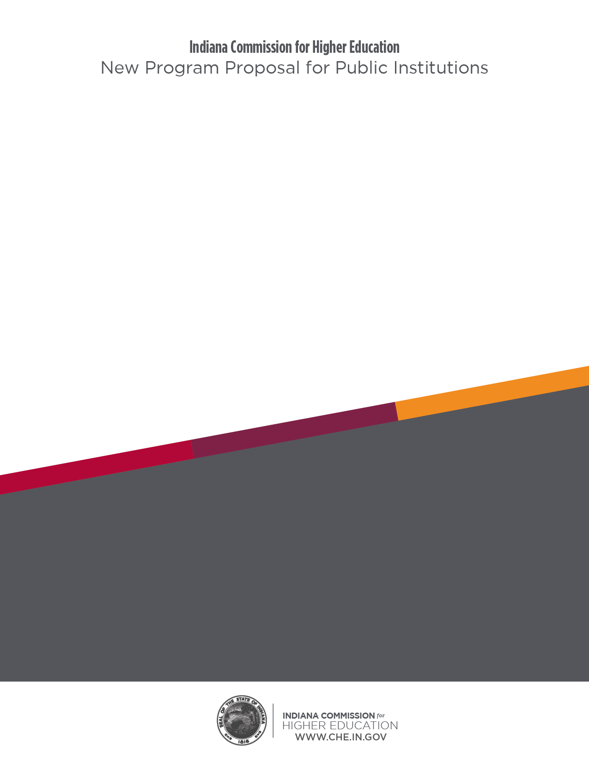

**[Program Name]**

**To Be Offered by [Institution] at [Campus]**

Degree Award Level:

Mode of Delivery (In-person or Online):

Career Relevant/Out-of-Classroom Experiences:

Academic Unit(s) Offering Program

College:

School:

Department:

Suggested CIP Code for Program:

**1. Program Description**

1. Provide a description of the program that would be available to prospective students and other interested stakeholders and that would be included on the institution’s web site and published to the Indiana Credential Registry.

**2. Rationale for the Program**

1. Rationale: General

* What problem is this program trying to solve?

1. Institutional Rationale

* How does this program build on institutional strengths and how is it consistent with the mission of the institution and the institution’s strategic plan (please provide a link to the strategic plan)?

1. State Rationale: General

* How does this program address state priorities as reflected in the Commission’s most recent strategic plan [*Reaching Higher In a State of Change*](https://www.in.gov/che/strategic-plan/reaching-higher-in-a-state-of-change/)?

1. State Rationale: Equity-Related

* How does this program address the Equity section of [*Reaching Higher In a State of Change*](https://www.in.gov/che/files/2019-20_Strategic_Plan_03-14-2020-spreads.pdf) (see pages 15-17), especially with respect to considerations of race/ethnicity, socioeconomic status, gender, and geography?

**3. Evidence of Labor Market Need**

1. National, State, or Regional Need

* Is the program serving a national, state, or regional labor market need?

1. Summary of Indiana DWD and/or U.S. Department of Labor Data

* Summarize the evidence of labor market demand for graduates of the program as gleaned from employment projections made by the Indiana Department of Workforce Development and/or the U.S. Department of Labor.

*Appendix 1: Summary of Indiana DWD and/or U.S. Department of Labor Data, Detail (This appendix should contain the detailed tables, upon which the summary of the labor market demand is based.)*

1. National, State, or Regional Studies

* Summarize any national, state, or regional studies that address the labor market need for the program.

*Appendix 2: National, State, or Regional Studies, Detail (This appendix should contain links to the studies cited and/or relevant pages from the studies themselves.)*

1. Surveys of Employers or Students and Analyses of Job Postings

* Summarize the results of any surveys of employers or students and analyses of job postings relevant to the program.

*Appendix 3: Surveys of Employers or Students and Analyses of Job Postings, Detail (This appendix should contain links to the surveys or analyses cited, and/or relevant pages from the documents themselves.)*

1. Letters of Support

* Summarize, by source, the letters received in support of the program, especially those written by external stakeholders.

*Appendix 4: Letters of Support, Detail (This appendix should contain the letters of support for the program.)*

**4. Cost of and Support for the Program**

1. Costs
2. Faculty and Staff

* Of the faculty and staff required to offer this program, how many are in place now and how many will need to be added (express both in terms of number of full- and part-time faculty and staff, as well as FTE faculty and staff)?

*Appendix 5: Faculty and Staff, Detail (This appendix should contain a list of faculty with appointments to teach in the program and a brief description of new faculty positions yet to be filled.)*

1. Facilities

* Summarize any impact offering this program will have on renovations of existing facilities, requests for new capital projects (including a reference to the institution’s capital plan), or the leasing of new space.

*Appendix 6: Facilities, Detail. This appendix should contain additional information on major impacts on facilities caused by this program.)*

1. Other Capital Costs (e.g. Equipment)

* Summarize any impact offering this program will have on other capital costs, including purchase of equipment needed for the program.

*Appendix 7: Other Capital Costs, Detail (This appendix should contain additional information on other capital costs associated with the program.)*

1. Support
2. Nature of Support (New, Existing, or Reallocated)

* Summarize what reallocation of resources has taken place to support this program.
* What programs, if any, have been eliminated or downsized to provide resources for this program?

1. Special Fees above Baseline Tuition

* Summarize any special fees above baseline tuition that are needed to support this program.

**5. Similar and Related Programs**

1. Similar Programs at Other Institutions
2. Similar Programs at Indiana Institutions

* Indiana institutions offering (on-campus and/or distance education) programs that are similar to the proposed program. If relevant, include information on topics such as: program options or specializations; institutional or programmatic accreditation; and preparation for licensure or certification.

1. Similar Programs at Institutions Outside Indiana

* Institutions in contiguous states, MHEC states, or the nation, depending upon the nature of the proposed program, offering (on-campus and/or distance education) programs that are similar to the proposed program. If relevant, include information on topics such as: program options or specializations; institutional or programmatic accreditation; and preparation for licensure or certification.

1. Related Programs at the Proposing Institution

* Identify programs at the proposing institution that compliment, strengthen, or otherwise would be impacted by the proposed program.

**6. Preparation for and/or Collaboration with Other Programs**

1. Preparation for Graduate Programs

* Does this program prepare students for one or more graduate programs? If so, please describe.

1. Articulation of Associate/Baccalaureate Programs

* **All institutions proposing associate or baccalaureate degrees must address program articulation pathways.**
* For each articulation agreement, indicate how many of the associate degree credits will transfer and apply toward the baccalaureate program.

*Appendix 8: Articulation of Associate/Baccalaureate Programs, Detail (This appendix should contain the actual articulation agreements relevant to the proposed program.) Prior to submitting the program proposal to the Commission, universities should work directly with Ivy Tech Community College and Vincennes University to develop articulation agreements that maximize transfer opportunities for students.*

1. Collaboration with Similar or Related Programs on Other Campuses

* Indicate any collaborative arrangements in place to support the program.

**7. Quality and Other Aspects of the Program**

1. Credit Hours Required/Time To Completion

* Credit hours required for the program and how long a full-time student will need to complete the program

*Appendix 9: Credit Hours Required/Time To Completion, Detail (This appendix should contain the semester-by-semester, course-level detail on the program curriculum, including how long it will take to complete the program, assuming full-time study.)*

1. Exceeding the Standard Expectation of Credit Hours

* If the associate or baccalaureate degree program exceeds 60 or 120 semester credit hours, respectively, summarize the reason for exceeding this standard expectation.

*Appendix 10: Exceeding the Standard Expectation of Credit Hours, Detail (This appendix should contain detailed information on why it is necessary to exceed the standard credit hour expectation, such as links to relevant licensure and/or accreditation standards the standards themselves.)*

1. Student Engagement Experiences with Career Relevance

The proposal should describe student engagement experiences with career relevance, which are described as ones that:

* Are rooted in an authentic real-world context and involves students in intentional reflection on that experience;
* Place an emphasis on the development of multiple career readiness competencies as defined by the National Association of Colleges and Employers (NACE); and
* Occur within traditional classroom environments and beyond the classroom settings either on or off campus or in virtual/online modalities.

1. Program Competencies or Learning Outcomes

* List the significant competencies or learning outcomes that students completing this program are expected to master, which would be available to prospective students and other interested stakeholders and which would be included on the institution’s web site and published to the Indiana Credential Registry..

1. Assessment

* Summarize how the institution intends to assess students with respect to mastery of program competencies or learning outcomes.

1. Licensure and Certification

Graduates of this program will be prepared to earn the following:

* State License:
* National Professional Certifications (including the bodies issuing the certification):
* Third-Party Industry Certifications (including the bodies issuing the certification):

1. Placement of Graduates

* Please describe the principal occupations and industries, in which the majority of graduates are expected to find employment.
* If the program is primarily a feeder for graduate programs, please describe the principal kinds of graduate programs, in which the majority of graduates are expected to be admitted.

1. Job Titles

* List specific job titles and broad job categories that would be appropriate for a graduate of this program.

1. Accreditation

* Accrediting body from which accreditation will be sought and the timetable for achieving accreditation.
* Reason for seeking accreditation.

**8. Projected Headcount and FTE Enrollments and Degrees Conferred**

* Report headcount and FTE enrollment and degrees conferred data in a manner consistent with the Commission’s Student Information System
* Report a table for each campus at which the program will be offered
* If the program is offered at more than one campus, a summary table, which reports the total headcount and FTE enrollments and degrees conferred across all locations, should be provided.
* Round the FTE enrollments to the nearest whole number
* If the program will take more than five years to be fully implemented and to reach steady state, report additional years of projections



“Program” refers to a certificate or degree that will be listed in the Commission’s Academic Program Inventory (API); the term does not include majors, tracks, specializations, or options, which should be listed in the program proposal. (see Glossary, under development).

Follow this format: [degree designation] in [field of study] e.g. A.S. in Nursing or B.S. in Business Administration

[Degree Award Level Definitions adapted from National Center for Education Statistics](https://www.in.gov/che/files/Degree-Award-Level-Definitions.pdf)

For Commission purposes, “online” includes two categories: 100% online and blended programs, i.e. 80-99% is online, with the remaining portion in-person.

Co-ops, internships, clinicals, practica, capstone projects, employer critiques, study abroad